**Building a personal finance tracker dashboard using Power BI**

I am in progress to build a personal finance tracker dashboard using Power BI to keep a track of the percentage I spent on each categories like shopping, food, bills, savings etc.

Firstly, I created an excel workbook to note down all the expenses, income and savings per month per year from the bank statement.

Open Power BI,

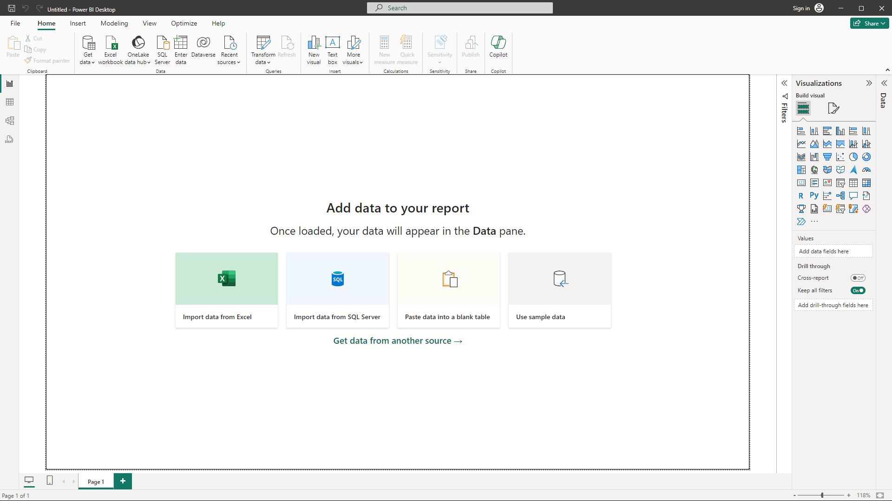

Click on the highlighted area to load the excel workbook.

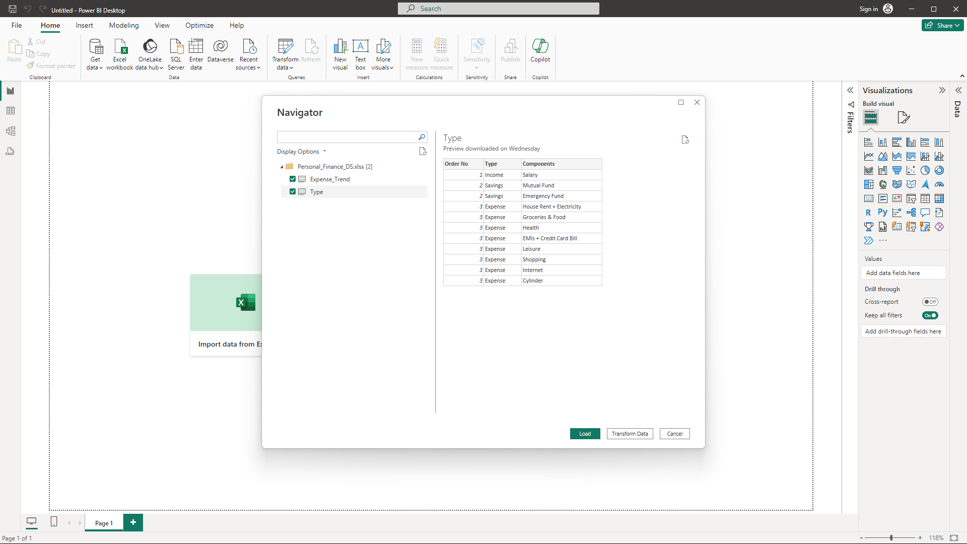

Choose the sheets you want to load/transform and then click on the load/transform data.

As you can now see the table are loaded.

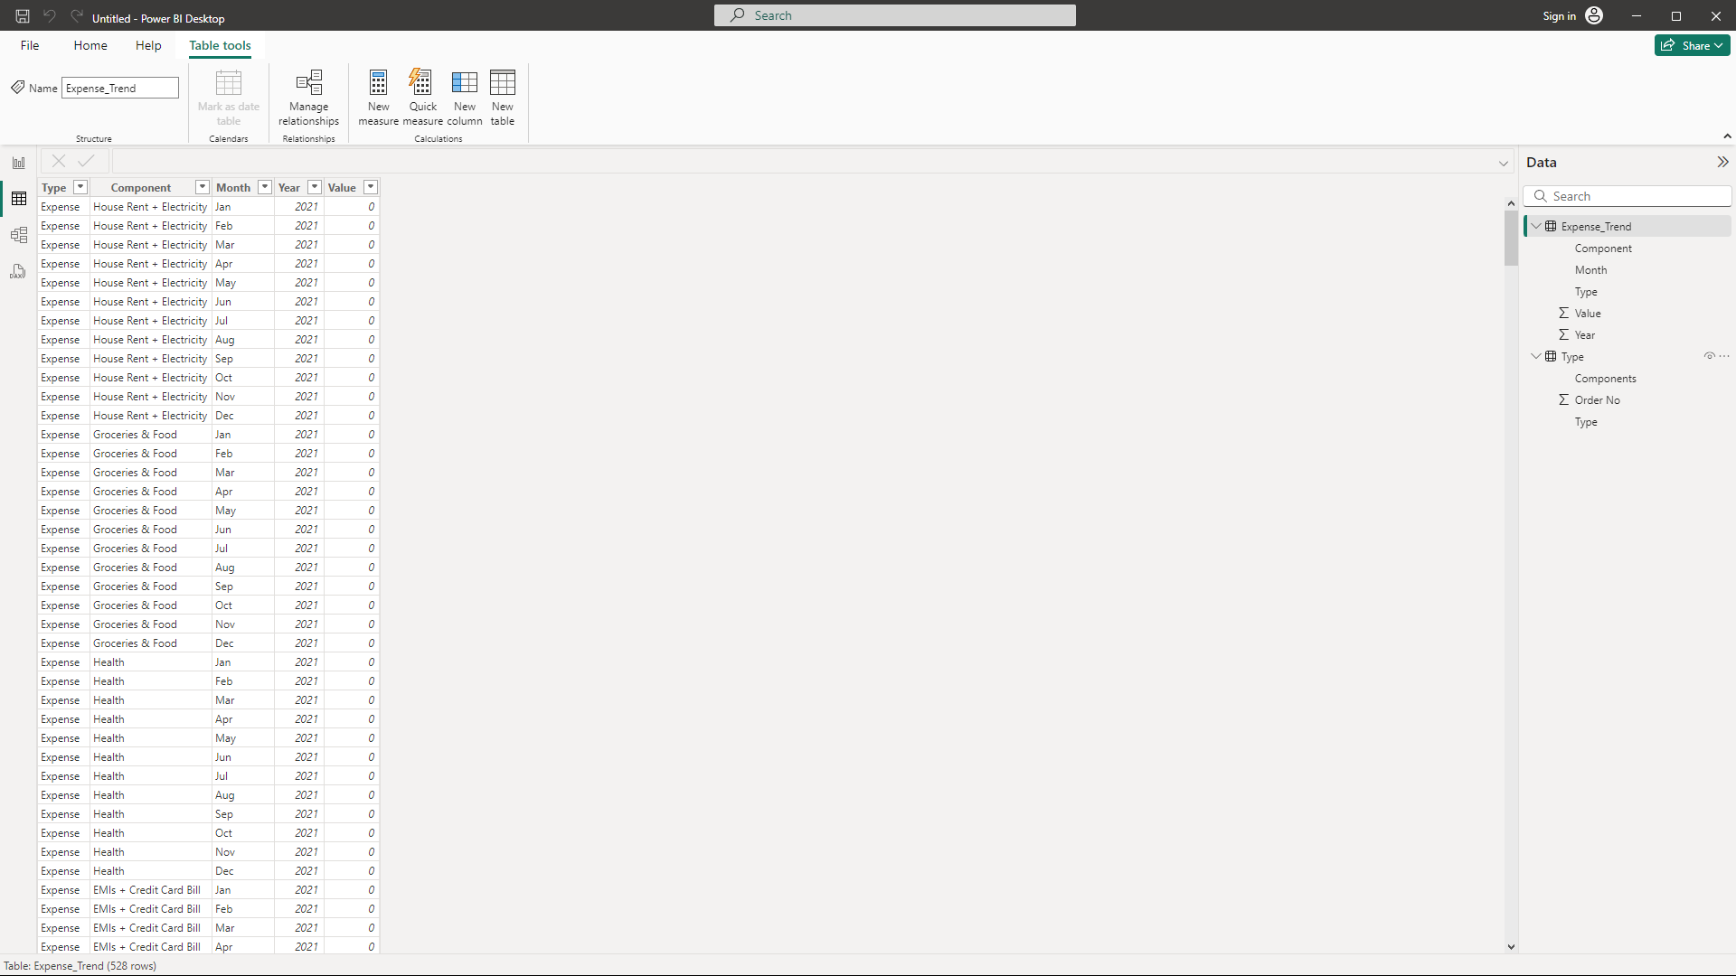

Now we shall add a new lookup table to store the month num and relate the month number column back to the primary table of Expense_Trend table. (Expense_Trend table is the primary table we will be using to build the dashboard)

Click on the “New Table” button on the ribbon above and write the below DAX query to create the lookup table named “MonthLookup”:

MonthLookup =

DATATABLE(

"MonthName", STRING,

"MonthNumber", INTEGER,

{

{"Jan", 1},

{"Feb", 2},

{"Mar", 3},

{"Apr", 4},

{"May", 5},

{"Jun", 6},

{"Jul", 7},

{"Aug", 8},

{"Sep", 9},

{"Oct", 10},

{"Nov", 11},

{"Dec", 12}

}

)

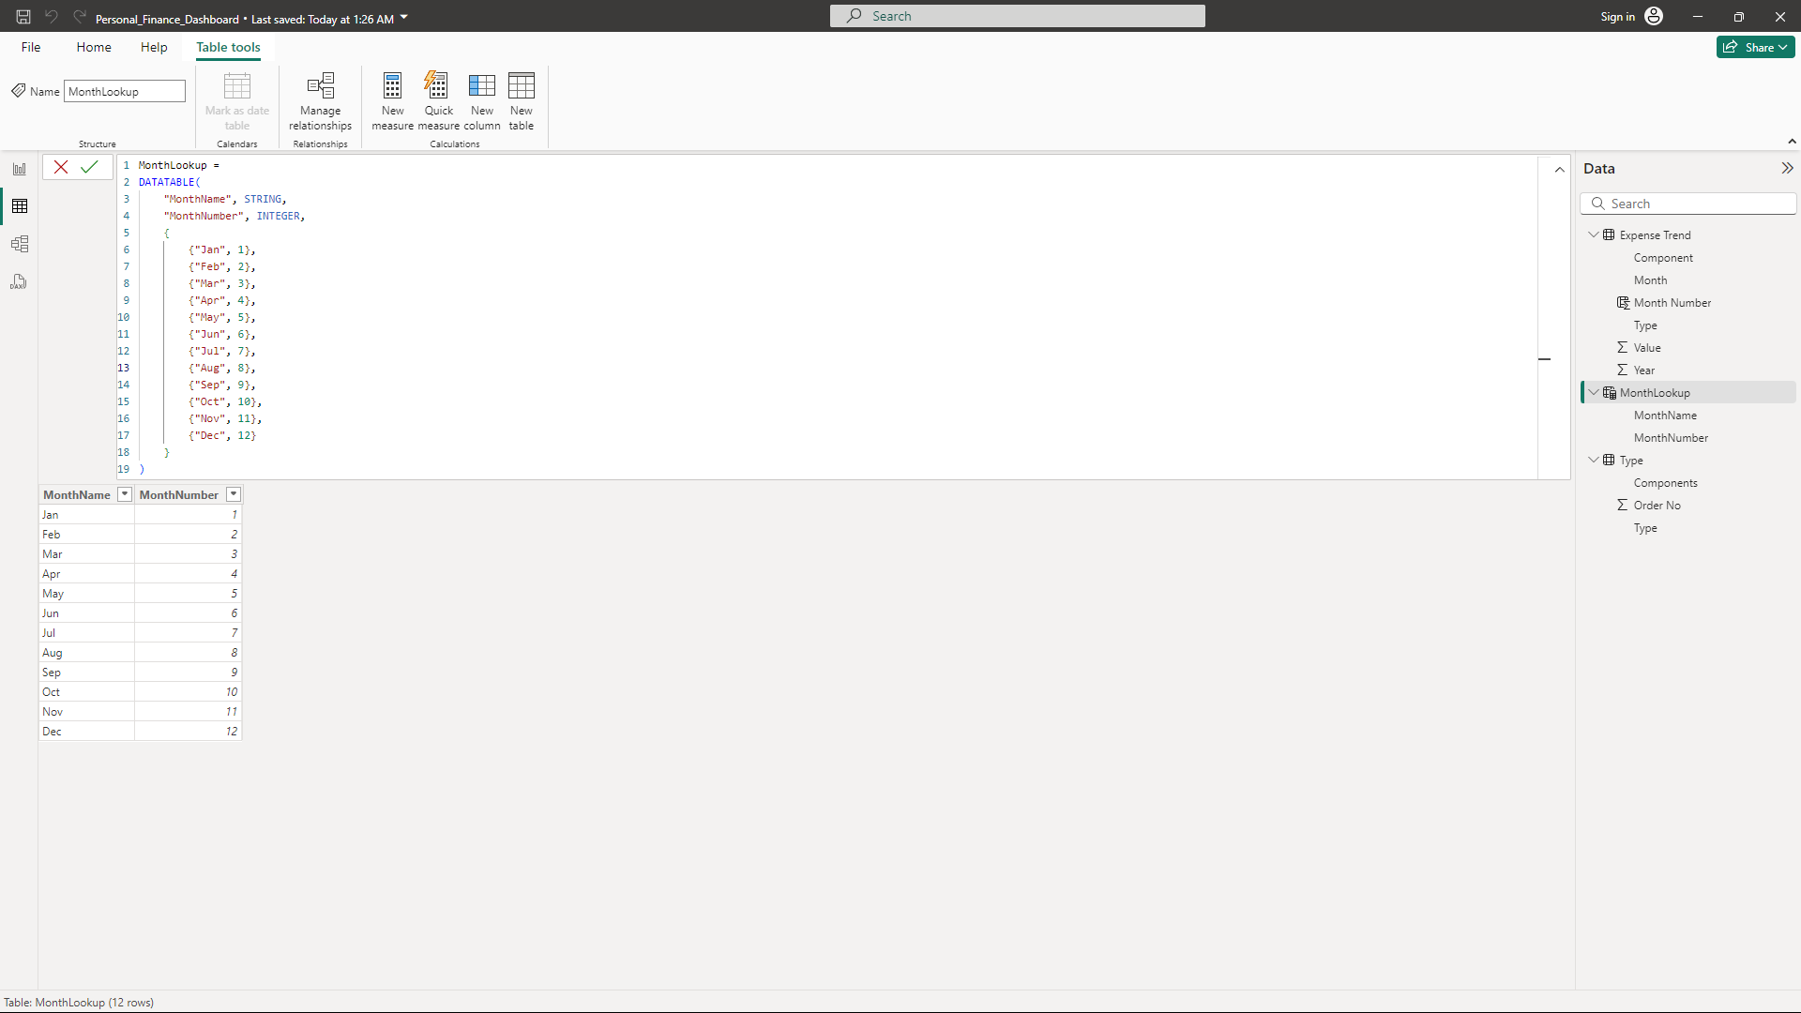

As seen above, a new table named “MonthLookup” has been created which contains two columns. One column stores the month name and the other column stores the number of the month.

To related this lookup table to the primary table, write the below DAX query:

Month Number = RELATED(MonthLookup[MonthNumber])

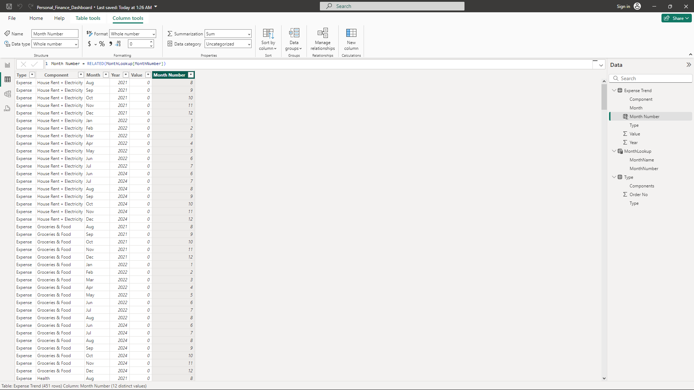

Now click the column name “Month” and sort the column by “MonthNum” by clicking on the “Sort by column” option on the above ribbon.

Now, you can use any charts for visualization. Now, the month will be align month-wise on the chart.

**Before After**

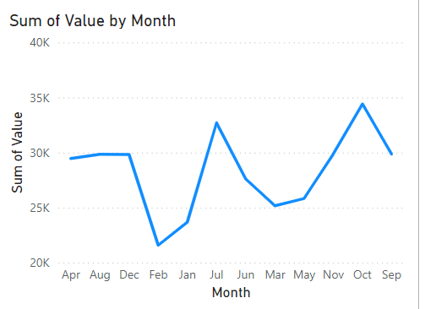 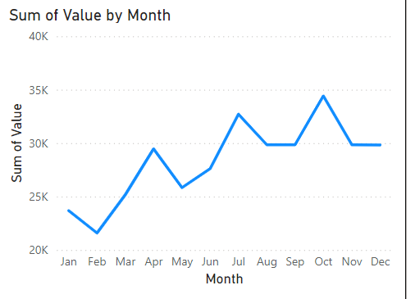

To display the percentage per value per year the following measure can be created,

Percent = sum('Expense_Trend'[Value])/(CALCULATE(sum('Expense_Trend'[Value]),FILTER(all('Expense_Trend'), 'Expense_Trend'[Year]=SELECTEDVALUE('Expense_Trend'[Year]))))

Choose the format of the “Percent” measure to percentage and set the desired decimal places.

You can now use the “Percent” measure on any visual,

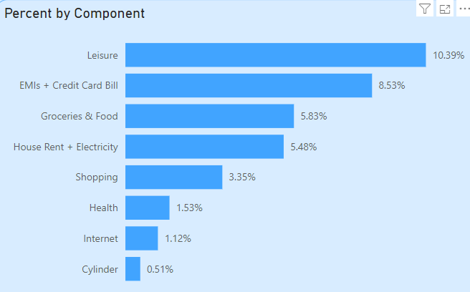

To create a card that displays only the sum of expenses, create a measure with the following DAX expression:

Expense = CALCULATE(SUM(Expense_Trend[Value]), Expense_Trend[Type] = "Expense")

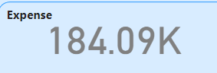

Same can be done Income and Savings.

To get the net saving records, create a measure with the following DAX expression:

Net Savings = [Income] - [Expense]

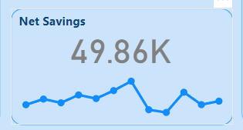

Hence gathering all visuals, the following dashboard is ready:

